LC#297 SERIALIZE AND DESERIALISE BINARY TREE
Serialization is the process of converting a data structure or object into a sequence of bits so that it can be stored in a file or memory buffer, or transmitted across a network connection link to be reconstructed later in the same or another computer environment.
Design an algorithm to serialize and deserialize a binary tree. There is no restriction on how your serialization/deserialization algorithm should work. You just need to ensure that a binary tree can be serialized to a string and this string can be deserialized to the original tree structure.
Clarification: The input/output format is the same as how LeetCode serializes a binary tree. You do not necessarily need to follow this format, so please be creative and come up with different approaches yourself.

Example 1:
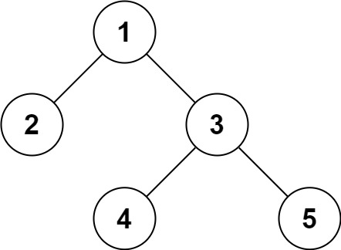
Input: root = [1,2,3,null,null,4,5]
Output: [1,2,3,null,null,4,5]
Example 2:
Input: root = []
Output: []

CODE: TC:O(N) SC:O(N)
->for serialization normal bfs method is ok but use a string builder
public class Codec {
public String serialize(TreeNode root) {
if(root==null)
return "";
StringBuilder res = new StringBuilder();
Deque<TreeNode> dq = new LinkedList();
dq.offer(root);

while(!dq.isEmpty())
{

TreeNode curr = dq.poll();
if(curr==null)
{
res.append("null,");
continue;
}
else
res.append(curr.val).append(",");
dq.offer(curr.left);
dq.offer(curr.right);
}
return res.toString();
}

public TreeNode deserialize(String data) {
if(data.equals(""))
return null;
String parts[] = data.split(",");
TreeNode root = new TreeNode(Integer.parseInt(parts[0]));
Deque<TreeNode> dq = new LinkedList();
dq.offer(root);
int i = 1;
while(!dq.isEmpty())
{
TreeNode top = dq.poll();
if(!parts[i].equals("null"))
{
TreeNode left = new TreeNode(Integer.parseInt(parts[i]));
top.left = left;
dq.offer(left);
}
i++;
if(!parts[i].equals("null"))
{
TreeNode right = new TreeNode(Integer.parseInt(parts[i]));
top.right = right;
dq.offer(right);
}
i++;
}
return root;
}}
LC#572 IS SUBTREE
Given the roots of two binary trees root and subRoot, return true if there is a subtree of root with the same structure and node values of subRoot and false otherwise.
A subtree of a binary tree tree is a tree that consists of a node in tree and all of this node's descendants. The tree tree could also be considered as a subtree of itself.

Example 1:
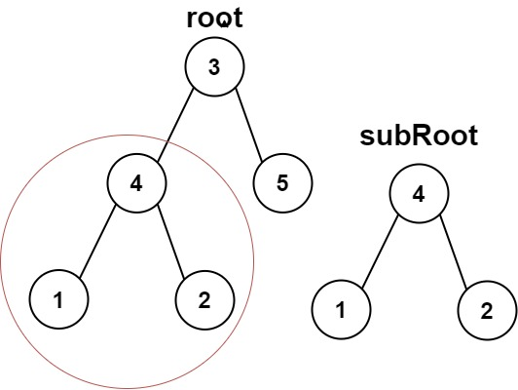
Input: root = [3,4,5,1,2], subRoot = [4,1,2]
Output: true

CODE: TC:O(N*M) SC : O(H)
class Solution {
public boolean isSubtree(TreeNode root, TreeNode subRoot) {
if (root == null)
return false;

return isSameTree(root, subRoot)
|| isSubtree(root.left, subRoot)
|| isSubtree(root.right, subRoot);
}

public boolean isSameTree(TreeNode root, TreeNode subroot) {
if (root == null && subroot == null)
return true;
if (root == null || subroot == null)
return false;
if (root.val != subroot.val)
return false;

return isSameTree(root.left, subroot.left) &&
isSameTree(root.right, subroot.right);
}
}

APP2: TC:O(n + m) , SC: O(n * m)
class Solution {
public boolean isSubtree(TreeNode root, TreeNode subRoot)
{
String s1 = serialize(root);
String s2 = serialize(subRoot);
return s1.contains(s2);
}
public String serialize(TreeNode node) {
if (node == null) return ",null";

return "," + node.val
+ serialize(node.left)
+ serialize(node.right);
}
}

LC#652 FIND DUPLICATE SUBTREES
Given the root of a binary tree, return all duplicate subtrees.
For each kind of duplicate subtrees, you only need to return the root node of any one of them.
Two trees are duplicate if they have the same structure with the same node values.

Example 1:
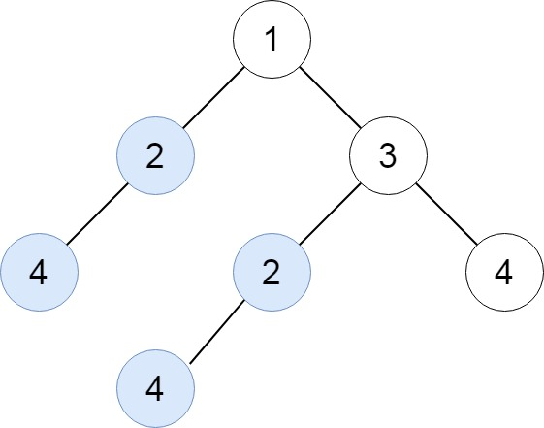
Input: root = [1,2,3,4,null,2,4,null,null,4]
Output: [[2,4],[4]]
APP:
->serialise the tree and then store it in a hash map if repeated add the node to the arraylist

CODE: TC:O(N) SC:O(N)
class Solution {
Map<String , Integer> hm = new HashMap();
List<TreeNode> res = new ArrayList();
public List<TreeNode> findDuplicateSubtrees(TreeNode root) {
serialise(root);
return res;
}

public String serialise(TreeNode root)
{
if(root==null)
return "null";

String path = serialise(root.left) +","
+ serialise(root.right)+","+ root.val;

int freq = hm.getOrDefault(path,0);
if(freq==1)
{
res.add(root);
}
hm.put(path , freq+1);
return path;
}
}

